ENSO Tracker
http://www.bom.gov.au/climate/enso/tracker/
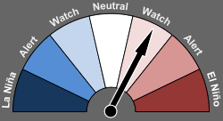
El Niño WATCH
Official status of the El Niño–Southern Oscillation
Chance of an El Niño in 2014 reduced
- The El Niño–Southern Oscillation (ENSO) Tracker status has been revised to El Niño WATCH level, meaning that there is at least a 50% chance of an El Niño occurring in 2014.
- Given recent easing in conditions and model outlooks, if an event was to occur it is unlikely to be strong.

The Indian Ocean Dipole (IOD) index has been below −0.4 °C (the negative IOD threshold) since mid-June, but needs to remain negative into August to be considered an event.
- Model outlooks suggest this negative IOD is likely to be short lived, and return to neutral by spring.
- A negative IOD pattern typically brings wetter winter and spring conditions to inland and southern Australia.

